CMSC 447 Group 4

Daniel Ackerson, Elizabeth Aucott, Steve Byerly, Kaitlyn Hackley, Zhaojie Jiang, Patrick Klenk

Requirements

1. The application shall be available to the user through a web interface.
   1. The application shall be able to run on Google Chrome version 64.\*.
   2. The application shall be able to run on Mozilla Firefox 58.\*.
2. The application shall be able to incorporate multiple datasets as sources of information.
   1. The application shall be able to incorporate json data.
   2. The application shall be able to incorporate csv data.
   3. The application shall be able to incorporate xml data.
   4. The application should be able to incorporate rdf data.
   5. The application shall be able to easily incorporate new data sources.
3. The application shall allow the user to input a search query through the web interface.
   1. The application shall except a variety of inputs.
   2. The application shall except inputs with differing degrees of flexibility.
   3. The application shall except inputs with differing scales.
   4. The application should allow the user to input meteorological search information.
      1. The application should allow the user to select a range of temperatures.
      2. The application should allow the user to select prefered weather conditions.
         1. The user should be able to specify the number of sunny days per year.
         2. The user should be able to select areas with low hazardous weather conditions.
   5. The application should allow the user to input cost of living information.
   6. The application should allow the user to input geographical information.
      1. The user should be able to select proximity of international airports.
      2. The user should be able to select proximity of sporting stadiums.
      3. The user should be able to select proximity of schools.
         1. The user should be able to select the prefered school ratings.
      4. The user should be able to select proximity of hospitals.
      5. The user should be able to select a range of population size.
      6. The user should be able to select proximity to religious landmarks.
      7. The user should be able to select proximity to ethnic communities.
   7. The application should allow the user to input crime rate information.
      1. The user should be able to specify the rate of drug arrests.
      2. The user should be able to specify the amount of sex offenders in the area.
      3. The user should be able to specify the rate of violent crime.
   8. The application should allow the user to search for political parties.
      1. The user should be able to select Blue vs. Red states.
      2. The user should be able to select Blue vs. Red counties.
   9. The application should allow the user to search for health hazards.
      1. The user should be able to search for a history of contaminants in the water.
      2. The user should be able to search for a history of CDC outbreaks.
4. The application shall output the most optimal locations for the user to live based on inputted data.
   1. The application shall display query results to the user through the web interface.
   2. The application should take no longer than 60 seconds to return and display a set of results for 95% of queries.

Preliminary Design

Simple inquiry page allows user to select a few parameters and not get overwhelmed.

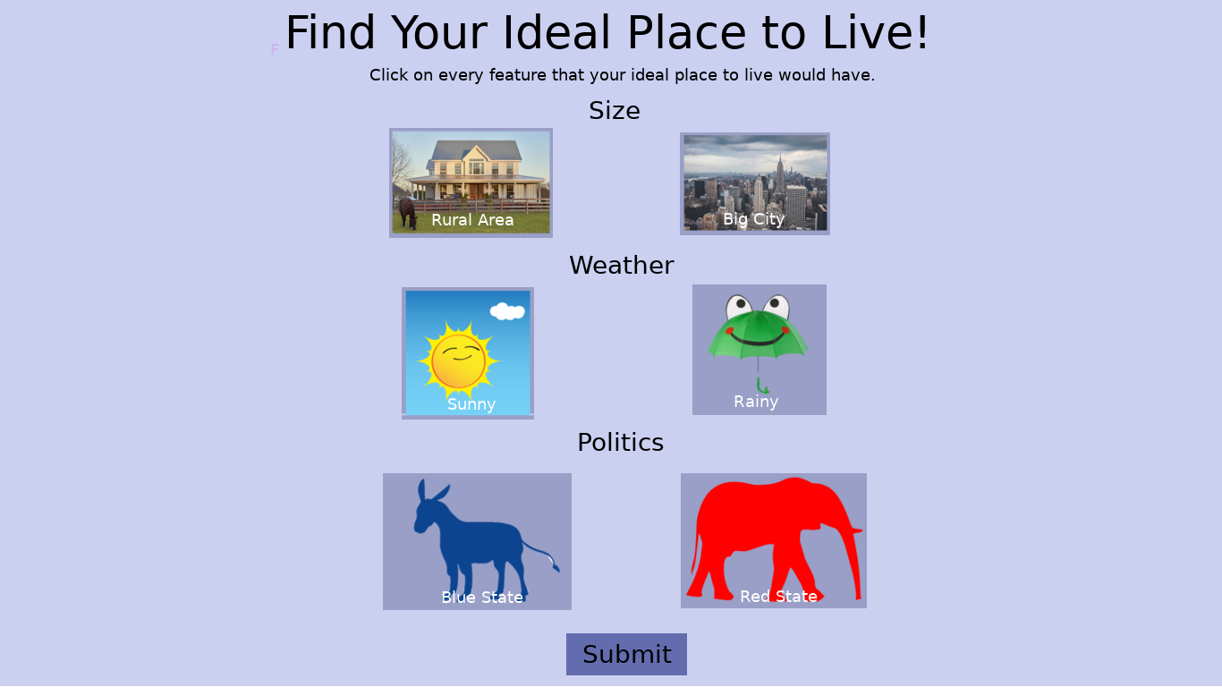

Results are displayed with a map, and more advanced filters can be applied to query to narrow results

